List: 16.6.23 Test: 23.6.23

Year 3 - ou words

|  |  |  |  |  |
| --- | --- | --- | --- | --- |
| young | double | touch | mention | natural |
| trouble | country | rough | naughty | therefore |

Year 3 challenge

How many words can you find using the ou pattern that makes an ‘u’ sound?

Year 4 un dis in re sub anti auto inter super – How many words can you make and learn?

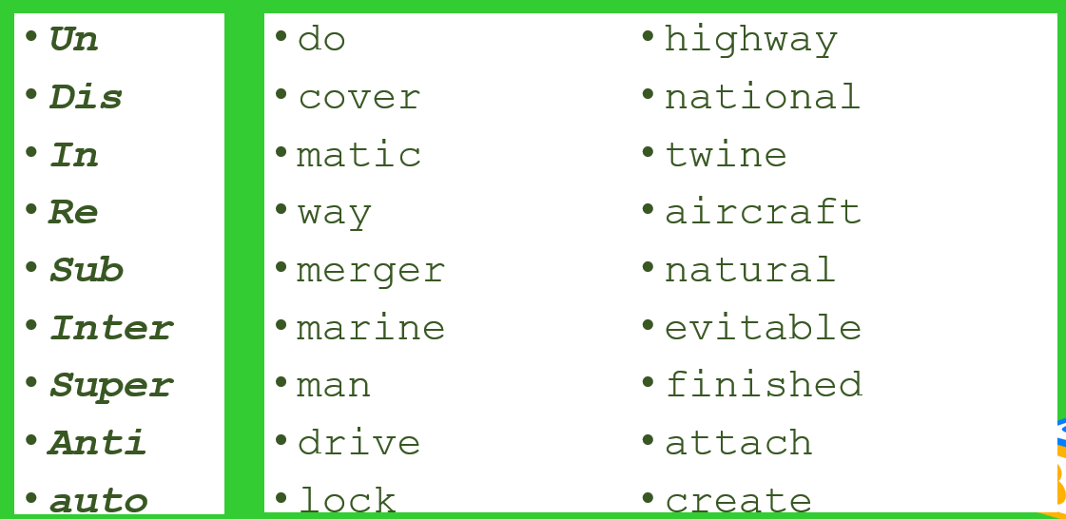

Edward and Finley

|  |  |  |  |  |
| --- | --- | --- | --- | --- |
|  |  |  |  |  |
|  |  |  |  |  |

Jacob

|  |  |  |  |  |  |
| --- | --- | --- | --- | --- | --- |
|  |  |  |  |  |  |