Year 3 and 4 Homework

Given out 9.6.23 Due back 16.6.23

English – Complete a role on the wall for Brer Rabbit. Remember what he looks like on the outside and his character and nature on the inside of the outline.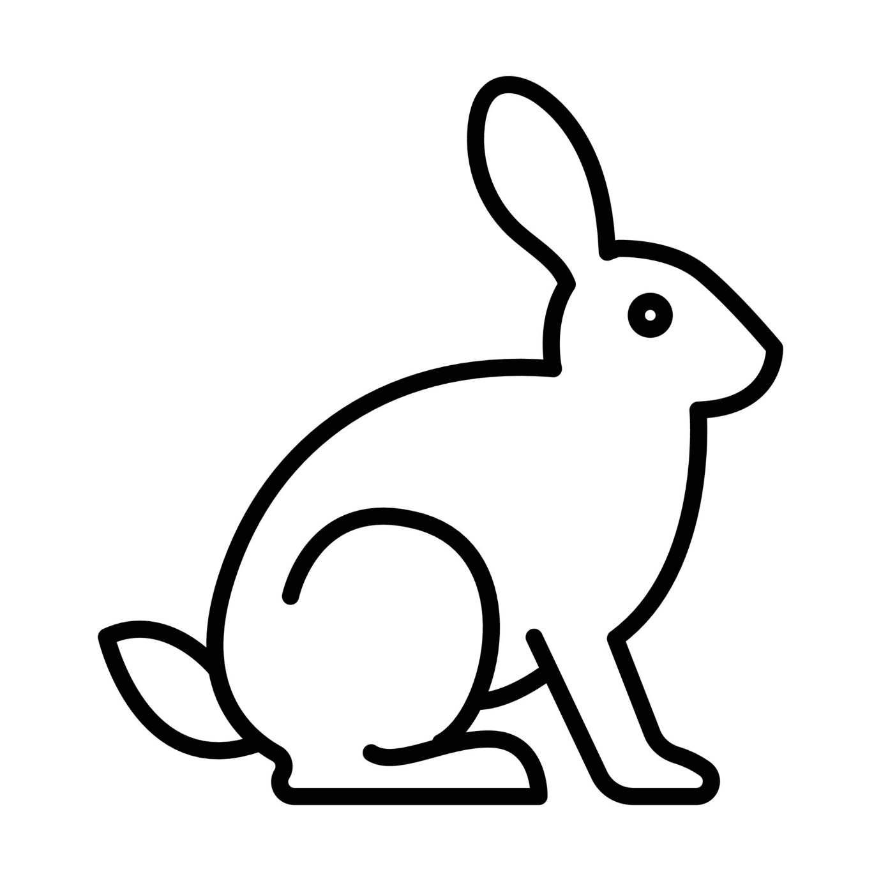

Maths

